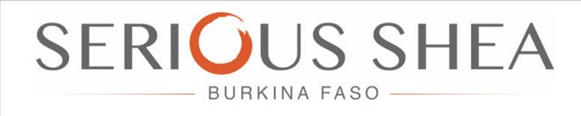

WOMEN’S GROUP FACILITATOR AGREEMENT

Updated March 2019

SCOPE OF WORK AGREEMENT

LEAD WOMEN’S GROUP FACILITATOR CONTRACT

APRIL 2019

SERIOUS SHEA ‘LEAD FACILITATOR’ CONTRACT

This Serious Shea Lead Facilitator Agreement (the “Agreement”) is made and entered into this 31st May 2017 (the “Effective Date”) between Serious Shea Limited with its principal place of business located at Ouagadougou, Secteur 29, 01 BP 6433 Ouagadougou 01 – Lot: 24 Section: XT Parcelle: 03 (the “Company”) and

………………………………………………………………… (Lead facilitator) of ………………………………………………………………….FBO/GROUP

NOW, THEREFORE, the Parties hereby agree as follows:

ENGAGEMENT AND SERVICES

Serious Shea wishes to recognize and appoint you as the Lead Facilitator for ………………………...which women’s group you are already a member of, (subject to your unconditional acceptance), for the purposes of processing shea butter (and other fruits) initiated by Serious Shea for the 2019 farming season.

RESPONSIBILITIES OF SERIOUS SHEA
Serious Shea will provide women’s groups with the following
1. Fruit-to-dried-kernel processing equipment
2. Access-to-market and premium prices for the dried kernels
3. 10% profit share in the butter profits
4. The opportunity to retain the dried kernels for personal use
5. Any other input (to be mutually agreed upon)
7. Similarly, all outputs or resultant produce after harvesting due Serious Shea under the project will be provided through the Lead Facilitator and/or Site Coordinators hired by Serious Shea to a designated warehouse.

RESPONSIBILITIES OF LEAD FACILITATOR
As lead facilitator, you faithfully undertake as follows:
- Confirm that all members of your group ……………………. are practiced shea kernel producers with at least 2 years’ experience in the shea sector.

2. They have access to suitable land for collection of shea fruit and that you have personally inspected the land and confirm it to be ………acres
3. Receive all inputs on behalf of women in my group and deliver the inputs to facilitators in the designated quantities and at designated times.
4. Shall keep proper records of all yields and payments received by …………………GROUP and confirm same to SC.
6. Promptly report any abnormal occurrences/events within the group to SC and alert Serious Shea or its agents accordingly.
7. Ensure that a min. 50% of shea kernels processed are sold to Serious Shea
8. Report all cases of side selling by group members to Serious Shea through the SC
9. Accept joint liability with women in my group for any losses to Serious Shea arising from irregular activities on the part of any group member.
10. Act generally as co-guarantors for all group members in respect of inputs/services received and the expected quantity of shea kernels as output from my group members under Serious Shea

INCENTIVES
i) A pair of wellington boots
ii) Overall (Clothing), specially marked with the designation ‘Lead Facilitator’
iv) Min. EUR0.5/kg of dried shea kernels
v) 10% profit share on the Serious Shea butter profits

LEAD FACILITATOR DETAILS

Full name: …………………………………………………………………………………..
Mobile phone No.: ……………………………………………………………………..
Region& District: ………………………………………………………………………..
Town/village: ……………………………………………………………………………..

I hereby certify that all information provided above are true and valid.

Lead Facilitator’s thumbprint/Signature: ….…………………………………

Site Coordinator Signature: …………………………………………………………

Serious Shea Representative: ………………………………………………………

Signed and dated in ………………, this ….. day of

